Official Program

Symposium On

“Combating Malaria in Post-Conflict Liberia: A Lesson for the Rest of Africa”
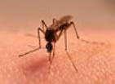

Mosquito: Malaria Conduit

Symposium jointly sponsored by

North Carolina A&T State University & the Liberian History, Education & Development, Inc. (LIHEDE)
in collaboration with Bennett College of Greensboro, North Carolina, Firestone Natural Rubber Company, SN Brussels Airlines, Bnettv.com, & The Association of United Liberians in The Triad, Inc.

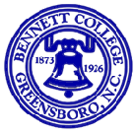

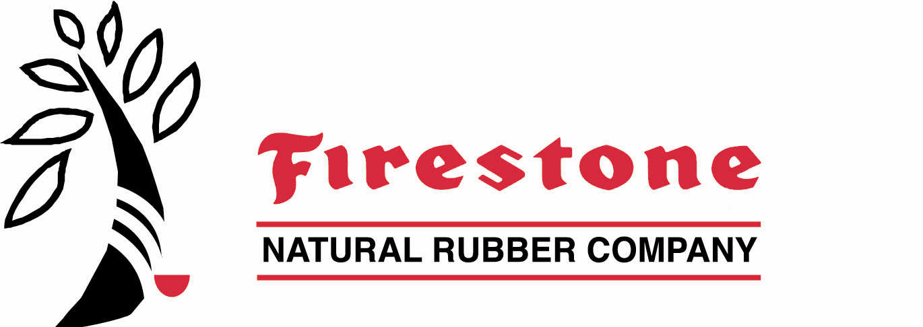

Date & Time
July 29, 2005 from 8:00 A.M. until 5:30 P.M.
July 30, 2005 from 8:00 A.M. until 5:30 P.M.

Moderator
Mr. Marvin Dickerson
Chairman of the Board of Directors
Liberian History, Education & Development, Inc. (LIHEDE)

Theme

Exploring Cutting-Edge Technologies for Malaria Treatment in Liberia

LIHEDE’s Board of Directors, Executive Officers, & Members

Officially Welcome You

to

Symposium 2005

on

“Combating Malaria In Post-Conflict Liberia: A Lesson for the Rest of Africa”
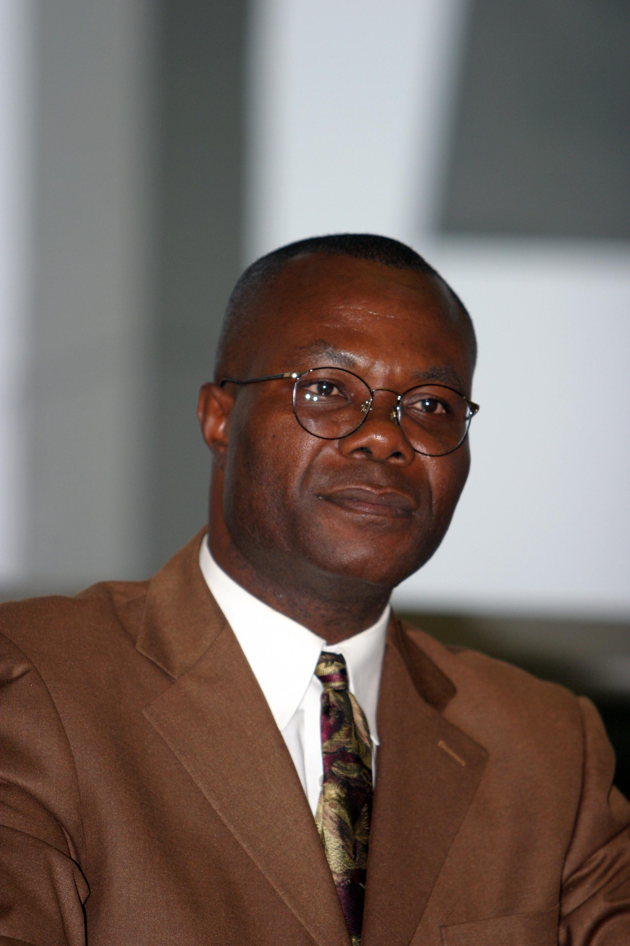
Syrulwa Somah, PhD
Executive Director & Co-Founder

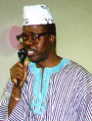
Siahyonkron Nyanseor
Treasurer & Co-Founder
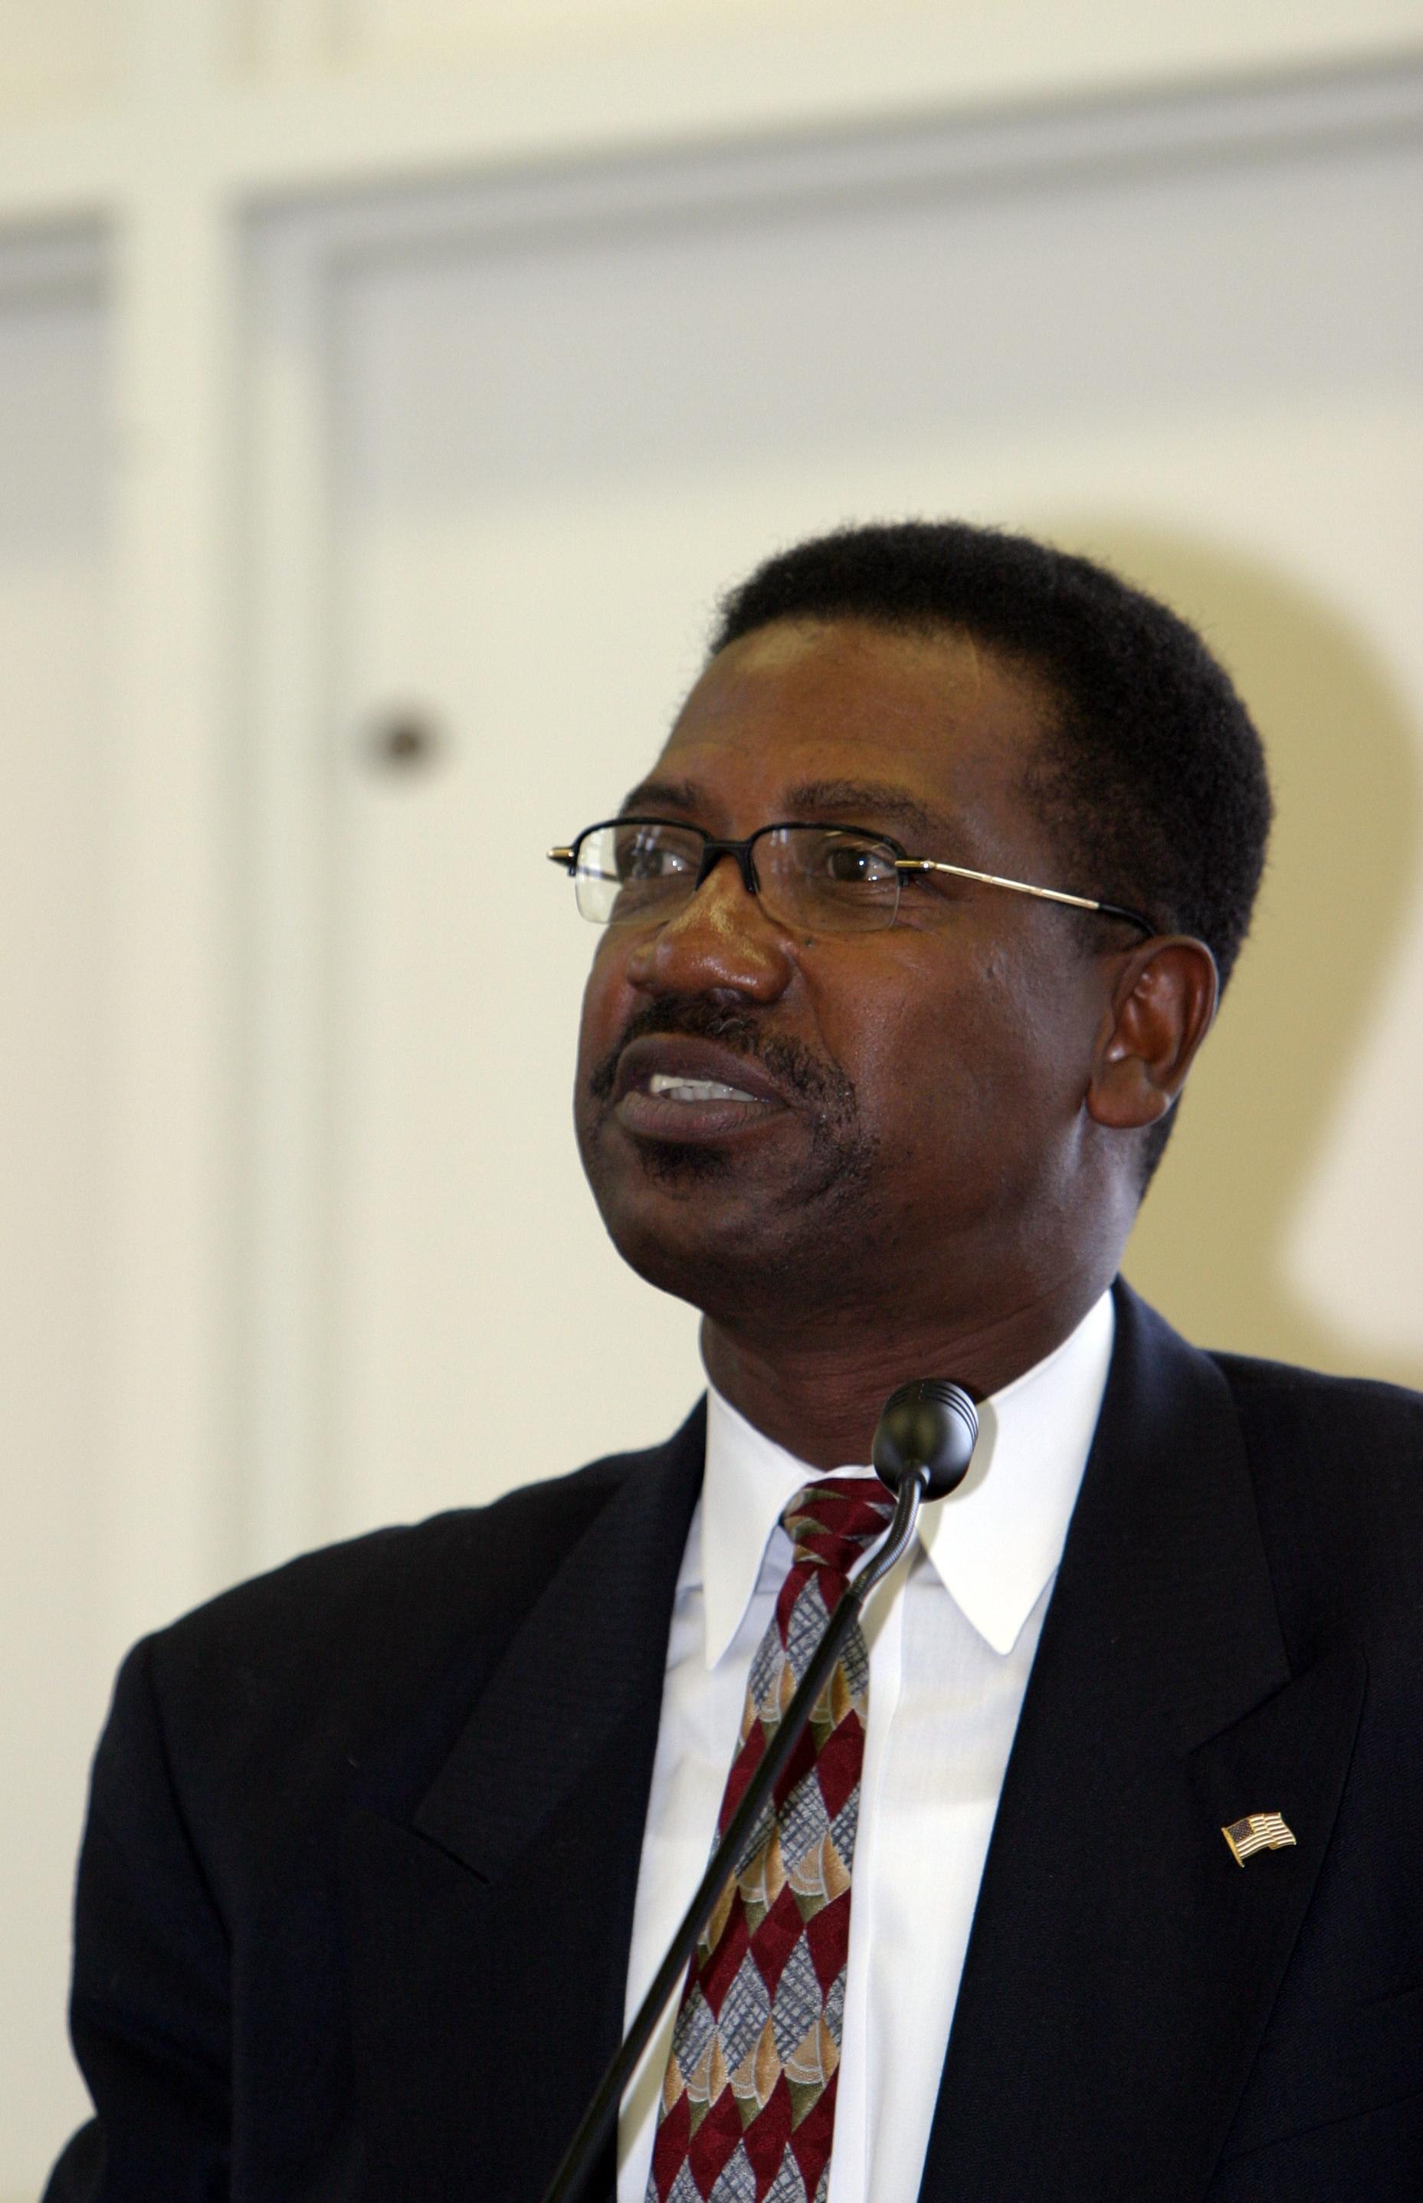
Marvin Dickenson
Chairman of the Board

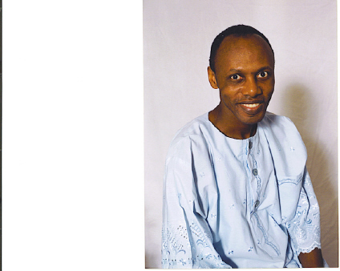
Nat Galarea Gbessagee

Secretary-General & Co-Founder

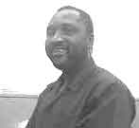
Sam Togba Slewion
Secretariat Member

Day I (Friday, July 29, 2005)

Part I
(Breakfast)

7:00 - 7:45 —Participants and Guests (Student Union Stalling Ball Room)

Part II

(Registration and Official Opening)

7: 45 -8:00 —Registration of Participants and Guests (Union Stalling Ball Room)

8:05 —Official Opening of Symposium—Mr. Marvin Dickerson

Chairman of the Board, LIHEDE & Masters of Ceremony

8:06-8:10 —Invocation—Rev. Wheigar J. Bright, Jr., Episcopal Church of the Redeemer, NC

8:12:8:36—Special Welcome Remarks

8:12 —Dr. Carolyn Myers, Provost, NC A&T State University

8:19 —Ms. Claudette Burroughs-White

for Mayor Keith Holiday, Mayor of the City of Greensboro, NC

8:26 —Dr. Claudette Williams, Executive Vice President, Bennett College

8:33 —NC Representative Earl Jones

8:40 —Mr. Sam DeShield, President, The Association of United Liberians In the Triad, Inc,
8:47— Dr. David Dillon, Chair, Department of Occupational Safety & Health, NC A&T Univ.

8:55-9:05—Introduction & Overview of Symposium/Themes & Rules

---Mr. Nat Galarea Gbessagee, Secretary General, LIHEDE

9:07-9:17— Introduction of Keynote Speaker -----Mr. Siahyonkron Nyanseor, Treasurer, LIHEDE

9:19-9:49— Keynote Address — Mr. Joseph M.N. Gbadyu, Former Superintendent (County

Executive) of Grand Bassa County, Republic of Liberia

Topic: Urgent Need for A Coherent National Health Policy in Liberia

9:51-10:01—Musical Selection: Ms. Twaleh Geply, Liberian Gospel Recording Artist

10:03-10:13— Brief Overview of Goals of LIHEDE & Recognition of Symposium Participants

---Dr. Syrulwa Somah, Executive Director, LIHEDE

10:15-10:42 —Photo-Shoots for Documentary (Mr. William Caranda)

Part III
(Presentation & Discussion of Symposium Topics -- Presenters, Moderator & Audience)

10:45 -1:00— Session I—Understanding and Coping with Malaria

10:45 —Presenter1: Dr. Delvin Walker, Fmr. Chairman, Dept. of Science,

Cuttington University College, Liberia

Topic: Environmental Risks of Mosquitoes Prevalence in Liberia

11:17—Presenter2: Dr. Thomas Jaye, Research Fellow, Birmingham University, United Kingdom

Topic: Understanding Malaria as a National Security Issue

11:49—Presenter3: Mr. Peter Burgress, Founder and New York Representative,

Transparency and Accountability Network (Tr-Ac-Net), USA

Topic: The Tragic Economic Impact of Malaria

12:21—Presenter4: Sam Gbutue Vorkpor, MD, MSPH

Chief Resident, Meharry Medical College, Division. of Preventive Medicine,

Dept. of Family and Community Medicine, USA

Topic: Epidemiological Evidence and Policy Implications of HIV/AIDS and Malaria

Interactions in Adults

12:51—Discussion/Question & Answer Period— Facilitator: Mr. James Hunder, Sr., Southern

Regional Vice President, Union of Liberian Associations in the Americas (ULAA).

Panelists: Dr. Delvin Walker; Dr. Thomas Jaye; Mr. Peter Burgress

1:05—Lunch Break (Union Hall Break Room)

2:10-5:00 —Session II – Malaria Control & Treatment Options

2:10—Presenter1: Robert S. Desowitz, PhD, DSc. Emeritus Professor of Tropical Medicine

and Medical Microbiology, University of Hawaii & Adjunct Professor of

Epidemiology, University of North Carolina, Chapel Hill, USA

Topic: Malaria Control-Research and Reality

2:42—Presenter2: Mr. Cyril Boynes, Jr., Director of International Affair, Congress of Racial Equality,

Topic: East African Experience in Malaria Prevention and Control: Lessons for Africans

3:14—Presenter3: Mr. Ken Carter, MPH, Director, Guilford County Environmental Health, USA

Topic: Prevention and Control in Endemic Areas

3:46— Presenter4: Ms. Nicole Williams, Howe Enterprise CT, USA

Topic: Malaria Control Is Now an Affordable Reality

4:18 Presenter5—Dr. Michael Berry, Investment Analyst and former Professor of Investments,

Colgate Darden Graduate School of Business Administration, University of Virginia

Topic: The Third Way: A New Approach Developing And Delivering Economical Drugs

4:50-—Discussion/Question & Answer Period— Facilitator, Ms. Marica Urey; Panelists: Robert

S. Desowitz, PhD; Mr. Cyril Boynes, Mr. Ken Carter, MPH, Ms. Nicole Williams

6:00-8:45p.m. —Banquet (Stalling Ball Room)

6:05— Invocation—Rev. Nelson Johnson, Pastor, Faith Community Church, Greensboro, NC

6:10-6:25—Musical Selection: Ms. Twaleh Geply, Liberian Gospel Recording Artist

6:30— 7:30—Banquet Service (Participants and Guests)

7:45— 7:55 Introduction of Keynote Speaker -----Nat Galarea Gbessagee

8:00-8:30— Keynote Address — C. William Allen, PhD., Minister of Information, Culture & Tourism,

Republic of Liberia

Topic: Forward March: Health & General Updates on Liberia

8:35-8:40—Vote of Thanks—Mrs. Mary Somah, wife of the LIHEDE Executive Director

8:45 —End of Day 1

Day II (Saturday, July 30, 2005)
Part I
(Breakfast)

7:00 - 7:45 — Participants and Guests (Student Union Exhibit Hall)

Part II
(Registration and Official Opening)

7: 45 - 8:00 — Registration of Participants and Guests (Union Exhibit Hall)

Part III
(Presentation & Discussion of Symposium Topics -- Presenters, Moderator & Audience)

8:00—Overview of Symposium/Theme and Rules

—Mr. Marvin Dickerson, Symposium, Moderator and Chairman, LIHEDE

8:15-12:00—Session I–Typhoid Fever & Clinical Manifestations of Malaria

8:16— 8:20— Introduction of Keynote Speaker ----- Ms. Hyla Bendu Weeks

Member, Women Healthcare International

8:21: — Keynote Address —Emmet A. Dennis, PhD., Professor and Dean, Rutgers University

College, Founder and Former Director, The Liberian Institute for Biomedical Research

Topic: “Malaria Endemicity in Liberia, A Research Agenda and Prospect for Control”

9:00—Presenter1: Lawrence A. Zumo, MD, Neurologist with sub-specialization in Autonomic

Nervous System Disorders, Syncope and HIV Neurology, USA

Topic: Cerebral Malaria, Clinical Manifestations, Neurologic and Neuropsychiatric

9:47—Presenter2: Francis N. Kateh, MD, MHA, Public Health Director, Anson County, USA

Topic: The Role of Typhoid Fever and Its Impact on the Diagnosis and Effective Treatment

of Malaria in Liberia

10:19—Presenter3: Abu Massalley, MD, Medical Services Coordinator, Step-by-Step, Inc., PA, USA

Topic: Collective Impact of Malaria on Society

10:51—Presenter4: Mr. Roger Bate, Director, Africa Fighting Malaria and Resident Fellow,

American Enterprise Institute, Washington, DC

Topic: Fighting Malaria in Africa: New Initiatives, Old Battles

11:25—Discussion/Question & Answer Period—Facilitator: Ms. Marcia Urey, Women Healthcare

International. Panelists: Sam Gbutue Vorkpor, MD; Lawrence A. Zumo, MD, and

Francis N. Kateh, MD

12:10—Lunch Break (Union Exhibit Hall)

1:15-3:00— Session II –Malaria, Pregnancy, and Women Issues

1:20—Presenter1: Eugenia Cooper, MD, Pediatrician

Topic: Impact of Malaria During Pregnancy

1:57—Presenter2: Ms. Muna Wreh, MPA, CSAC

(with Roberta Rashid, Mydea Reaves-Karpeh, Nancy Mensah Bright, & Doris Parker)

Topic: The Emotional Toll of Malaria: Voices of Liberian Women

2:45—Announcements---Dr. Syrulwa Somah

2:55—Vote of Thanks---Mr. Sam Togba Slewion

3:05—Resolution Committee Meeting (Nat Galarea Gbessagee, Mr. Sam Togba Slewion,

Siahyonkron Nyanseor, Mydea Reaves-Karpeh, Muna Wreh, and Josephine Shannon)

4:30-6:15— Session III: Soccer Tournament (Smith High School Field)

Club Bassa vs. Liberian FC of Salisbury

Awarding of Trophy to Winner

7:25-3:40 A.M. — Evening Affairs

Liberia’s 158th Independence Day Celebration & Ball

Hosted by The Association of United Liberians In The Triad, Inc. & The Liberian Community of Greensboro

Emmanuel Temple Ball Room

1129 Jefferson Road (off Friendly Ave)

Greensboro, North Carolina

Donation: $15.00 Per Person

--Food and Drinks will be served

---Address by Mr. Sam DeShield, President, The Association of United Liberians In The Triad, Inc,

LIHEDE Board of Directors

Mr. Marvin Dickerson, Chairman

Msgr. Robert G. Tikpor, PhD., Member

Rev. Joseph Gbadyu, Member

Professor Yancy Peter Flah, Member

Rev. Emmanuel Bowier, Member

Ms. Josephine Shannon

Syrulwa Somah, PhD, Ex-Officio-Member

Nat Galarea Gbessagee, Ex-Officio-Member

Siahyonkron Nyanseor, Ex-Officio-Member

List of Participating Institutions

African Broadcasting Network

African Services Coalition

Bnettv.Com, Inc.

Club Bassa Soccer Association

Congress of Racial Equality

Daily Observer

Faculty and Students, Bennett College

Grand Gedeh County Association

Liberia Peace Institute

Liberian Association of Charlotte

Liberian Association of Durham

Liberian Association of Greensboro

Liberian Association of Winston-Salem

Liberian First Organization

Liberian Soccer Association of Salisbury

Maryland County Association of USA

NC A&T OSH Student Club

NC A&T School of Technology

Raleigh-Durham (LF Soccer Association)

Sinoe County Association

The EMCOMPASS GROUP

UNIBOA (United Bassa Association of America)

United Bong County Association in the America

WNNA 90.1

Symposium Organizing Committee

Mr. Nya Flomo, Chairman

Ms. Patricia White

Ms. Brooke Patterson, Member

Ms. Devolia Sweet

Mr. Nat Galarea Gbessagee, Member

Ms. Wanda Watford, Member

Mr. Sam Togba Slewion, Member

Dr. Syrulwa Somah, Member

Symposium Sponsors

Firestone Natural Rubber Corporation

LIHEDE

SN Brussels

Bennett College

NC A&T State University

The Executive Officers, Board of Directors, and Members

of the

Liberian History, Education & Development, Inc. (LIHEDE)

Extend Heartfelt Thanks and Appreciation To You

for making

Symposium 2005 A Great Success

Please Come Again Next Year for Symposium 2006

Please visit www.lihede.org for upcoming events by LIHEDE

